BETAMETHASONE IN HARNESS RACING:
High levels of athletic exertion are accompanied by stress, which takes its toll on every system of the athlete. Horses are no exception (MacNichol et al., 2018). An entire science of sports medicine has developed to prevent and alleviate exercise related problems that affect athletes, and equine sports medicine has not been left behind. The stress of exercise causes the release of numerous inflammatory mediators. These mediators may be short-lived and the athlete rapidly recovers, but in some cases they may initiate cartilage damage and ultimately osteoarthritis. Over 53% of racehorses (Jeffcott, 1982) experience lameness during their racing careers, of which joint injury is one of the major causes. As many as 27% of Thoroughbred yearlings go through the sale with pre-existing arthritis (Preston, 2010), and this phenomenon is not limited to Thoroughbreds as a comparable 33% is seen in young horses of non-racing breeds (Björnsdóttir et al., 2000).
Betamethasone was the first corticosteroid developed for use in the intra-articular treatment of osteoarthritis (Husby et al., 1975), and has long been used as the standard against which other intra-articular therapies are compared (Lindholm et al., 2002; Bellamy et al., 2006). While in vitro studies suggest that betamethasone may adversely affect chondrocyte viability (Dragoo et al., 2012, Zhu, 2015), there does not appear to be a similar effect in horses in vivo. In normal horses, it has been suggested in a PhD dissertation that betamethasone injection may be deleterious to cartilage (Zhu, PhD Thesis 2015), but these data have never been reviewed by the standard peer-review process, because none of this work has been published in the scientific literature, see attachment #1, below.
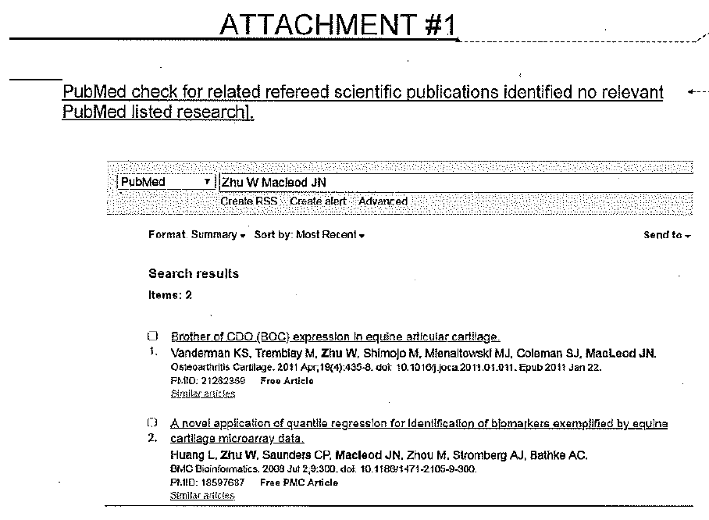
In contrast to this unpublished study performed in horses with normal joints, horses with experimentally induced osteochondral fragments do not demonstrate similar deleterious effects (Foland et al., 1994).
In human medicine, rest for 24 hours after joint injection is recommended (Chakravarty et al., 1994), a common recommendation for equine athletes as well. In horse racing, regulatory veterinarians have urged that joint injections be administered outside of the entry process, permitting the practitioner to assess response to therapy before racing. The RMTC has chosen 7 days as a period that permits this assessment, but provides no scientific or other rationale for this 7 day period. This is considerably longer than the 24 hours recommended in human medicine. Since the time between entries and racing is usually 3 – 4 days, a 6 or 6 ½ day withdrawal would permit sufficient time for injection, assessment and then entry. The additional advantage of a 6 or 6 ½ day withdrawal is that Standardbreds are unique in that they race weekly, and this withdrawal period would permit appropriate therapy and assessment without interfering with a weekly racing schedule.
The RMTC betamethasone withdrawal study has not been published, but the recommendation is for 9 mg in a single articular space (ARCI Controlled Therapeutic Medication Schedule). In a pharmacokinetic study evaluating methylprednisolone administration into two anatomically different joints, it has clearly been demonstrated that the kinetics were different between the two different joints (Machin et al., 2018; Knych et al., 2014) and there is no reason to believe that multiple joints were evaluated for betamethasone either. In Machin et al. (2018), joint injection into the metacarpophalangeal (fetlock) joint resulted in rapid plasma clearance of the drug. If this phenomenon is the same with betamethasone, and the metacarpophalangeal joint is the one used in the RMTC study, then injection into all other joints with betamethasone would result in risk of a positive test. Further, the combination of betamethasone with hyaluronic acid, a practice long considered “Best Practice” in equine sports medicine, may result in prolonging the withdrawal (Knych et al., 2016, Machin et al., 2018).
Differences in pharmacokinetics between not only the intercarpal and radiocarpal joints, but also among the other joints which may require injection need to be taken into consideration when determining a threshold. Machin et al. (2018) showed a substantial difference between plasma concentrations of methylprednisolone depending upon which joint is injected. The stifle joint exhibited a particularly high mean and standard deviation of serum concentration. Betamethasone is the safest of the FDA approved intra-articular corticosteroids, and as such, it makes the most sense to have a higher dose available for use in inflamed stifles in horses, because of the slower elimination of corticosteroids from the stifle. Thresholds set for stifle therapy for the other available intra-articular corticosteroids would unrealistically permit their widespread use in other joints.
The RMTC makes the argument that a betamethasone threshold of 100 pg/mL would permit joint injection too close to racing to prevent the masking of lameness. However, the injection of 15 mg into joints with experimentally induced osteochondral fragments failed to mask lameness at any time point (Foland et al., 1994). Further, as demonstrated in Machin (2018), the RMTC threshold for methylprednisolone fails to prevent the use of methylprednisolone in fetlock joints within 6 days of racing, while making its withdrawal in distal hock joints impossible to predict. The RMTC recognizes the requirement for practitioners to use corticosteroids for special procedures, such as high suspensory infiltration, and therefore, isoflupredone was chosen for this purpose. The RMTC regulations fail to permit any corticosteroids for reasonable use in the very large stifle joints. Dr. Gary White, the clinical researcher who performed much of the research on the BetaVet equine formulation of betamethasone, recommends the use of 15 mg of the BetaVet product per stifle joint. The adoption of the 100 pg/mL threshold for betamethasone would permit the use of the safest FDA approved intra-articular corticosteroid for use in stifles at a withdrawal time that would permit the practitioner to assess response to therapy before racing, and still meet the racing schedule of the Standardbred racehorse.
The suggested dose of 30 mg is consistent with the published literature, reflecting practitioner judgement (Menendez et al., 2015, Knych et al., 2016). The original RMTC Advisory Committee similarly recommended a dosage of 6-30 mg IA SID, [Attachment #2] which dose was also the AAEP recommended dose as in Attachment #3 Tobin et al, “World Rules for Equine Drug testing and Therapeutic Medication” which document also shows that the regulatory thresholds in place in Ohio and Arizona were 60 ng/ml in plasma. Additionally, the Attachment #2 RMTC 2006 working document shows that the published withdrawal time guidelines in place for betamethasone in 2006 were 24-36 hours, consistent with the published urinary threshold of 60 ng/ml.
In conclusion, the USTA recommendation:
- Falls in line with practitioner recommendations on dose.
- Permits targeted therapy of stifles
- Permits the veterinary practitioners to assess response to treatment before entry or racing.
- Does not endanger horses by masking lameness.
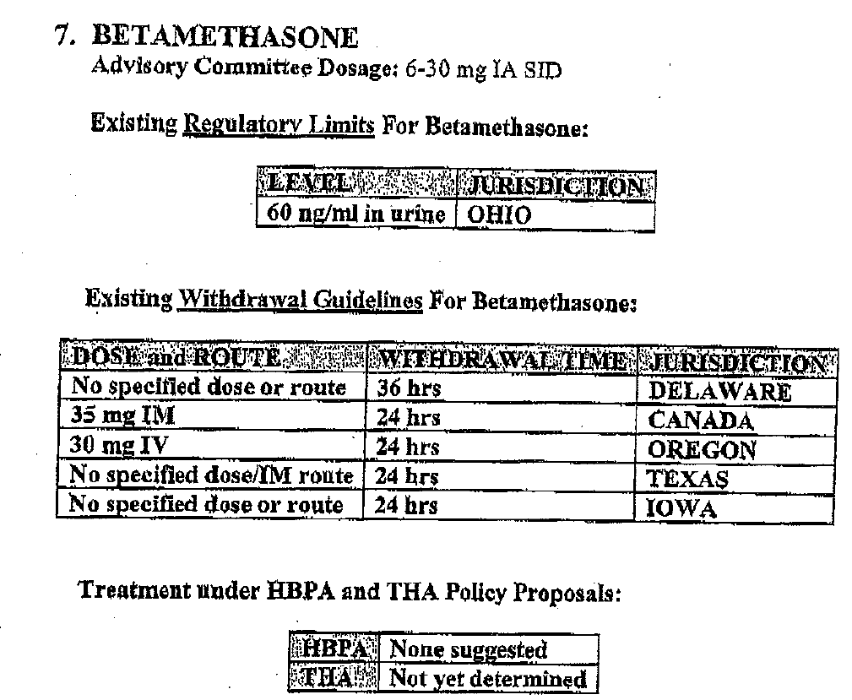
Attachment #2: RMTC working document including the dose and suggested withdrawals for betamethasone.
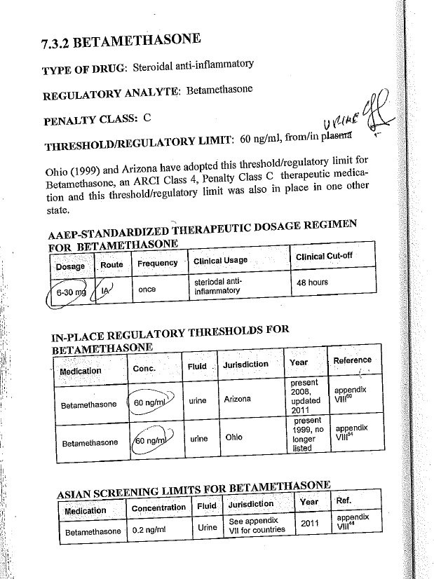

Literature cited
1/ MacNicol JL, Lindinger MI, Pearson W. 2017. A time-course evaluation of inflammatory and oxidative markers following high-intensity exercise in horses: a pilot study. J Appl Physiol 124: 860 –865, 2018. doi:10.1152/japplphysiol.00461.2017.
2/ Jeffcott LB, Rossdale PD, Freestone J, Frank CJ, Towers-Clark PF. 1982. An assessment of wastage in Thoroughbred racing from conception to 4 years of age. Equine Vet. J. 14(3):185-198.

3/ Preston SA, Zimmel DN, Chmielewski TL, Trumble TN, Brown MP, Boneau JC, Hernandez JA. 2010. Prevalence of various presale radiographic findings and association of findings with sales price in Thoroughbred yearlings sold in Kentucky. J Am Vet Med Assoc.Feb 15;236(4):440-5. doi: 10.2460/javma.236.4.440.

4/ Björnsdóttir S, Axelsson M, Eksell P, Sigurdsson H, Carlsten J. 2000. Radiographic and clinical survey of degenerative joint disease in the distal tarsal joints in Icelandic horses. Equine Vet J. May;32(3):268-72.

5/ Husby G, Kåss E, Spongsveen KL. 1975. Comparative double-blind trial of intra-articular injections of two long-acting forms of betamethasone. Scand J Rheumatol;4(3):118-20.

6/ Lindholm AC, Swensson U, de Mitri N, Collinder E. 2002. Clinical effects of betamethasone and hyaluronan, and of defocalized carbon dioxide laser treatment on traumatic arthritis in the fetlock joints of horses. J Vet Med A Physiol Pathol Clin Med. May;49(4):189-94.

7/ Bellamy N, Campbell J, Robinson V, Gee T, Bourne R, Wells G. 2006. Intraarticular corticosteroid for treatment of osteoarthritis of the knee Cochrane Database Syst Rev. Apr 19;(2):CD005328.

8/ Dragoo JL, Danial CM, Braun HJ, Pouliot MA, Kim HJ. 2012. The chondrotoxicity of single-dose corticosteroids. Knee Surg Sports Traumatol Arthrosc. Sep;20(9):1809-14. doi: 10.1007/s00167-011-1820-6. Epub 2011 Dec 21.

9/ Zhu W. 2015. Glucocorticoid-induced chondrocyte cytotoxicity at doses recommended for intra-articular therapy in horses. Theses and dissertations—Veterinary Science. https://uknowledge.uky.edu/gluck_etds/23

10/ Foland JW, McIlwraith CW, Trotter GW, Powers BE, Lamar CH. 1994. Effect of betamethasone and exercise on equine carpal joints with osteochondral fragments. Vet Surg. Sep-Oct;23(5):369-76.

11/ Chakravarty K, Pharoah PD, Scott DG. 1994. A randomized controlled study of post-injection rest following intra-articular steroid therapy for knee synovitis. Br J Rheumatol. May;33(5):464-8.

12/ Knych HK, Stanley SD, Harrison LM, McKemie DS. 2017. Pharmacokinetics of betamethasone in plasma, urine and synovial fluid following intra-articular administration to exercised Thoroughbred Horses. Drug Testing and Analysis 9:1385-1391.

13/ Machin J, Duer W, Maylin G, Fenger C, Wilson D, Ivey M, Berthold B, Allison S, Tobin T. 2018. Variability in plasma concentrations of methylprednisolone 6 days after intrasynovial injection of methylprednisolone acetate in racing horses: A field study. Equine Vet J. 2018 Aug 6. doi: 10.1111/evj.13003.

ATTACHMENT #1

PubMed check for related refereed scientific publications identified no relevant PubMed listed research].

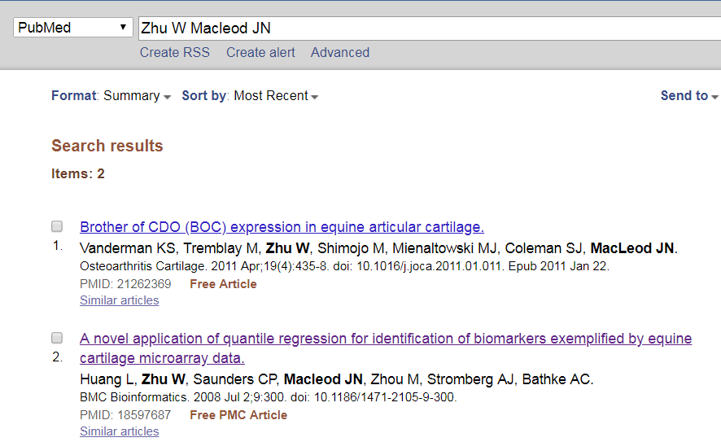

ATTACHMENT #2

This suggested dose is fully consistent with the original RMTC Advisory Committee dosage of 6-30 mg IA SID, [Attachment #2]

ATTACHMENT #3

which dose was also the AAEP recommended dose as in Attachment #3 Tobin et al, “World Rules for Equine Drug testing and Therapeutic Medication” which document also shows that the regulatory thresholds in place in Ohio and Arizona were 60 ng/ml in plasma.

