Appendix A:
Manuscripts assigned to Editor-in-Chiefs and Typical Turnaround Times for Comparative Exercise Physiology:
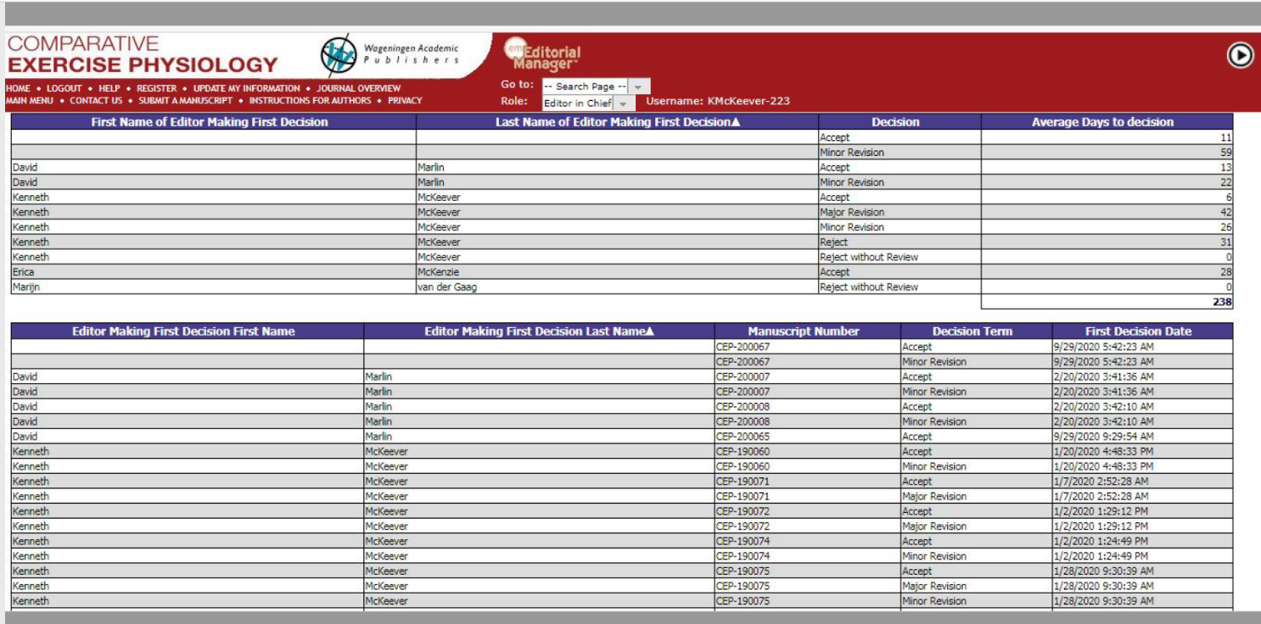

Appendix B:
RMTC Controlled Therapeutic Medication Dose/Dosage That Do Not Adhere To Label Dose or
Veterinary Medical Recommendations
RMTC Substance | Recommended Dose |  | RMTC dose matches R.D. | Reference
Acepromazine | 0.04 to 0.08 mg/kg |  | yes* | Label dose
Albuterol | 360 mcg inhaled dose |  | no | Derksen et al., 1999
Betamethasone | 9 to 18 mg |  | yes* | Label dose
Butorphanol | 0.1 mg/kg |  | yes | Label dose
Cetirizine | 0.2 - 0.4 mg/kg |  | yes | Olsen et al., 2008
Cimetidine | 20 mg/kg q8h |  | no | Nieto et al., 2001
Clenbuterol | .8 mcg 2X daily |  | Yes* | Label dose
Dantrolene | 800 mg |  | no | Edwards et al., 2003
Detomidine | 10 to 20 mg |  | no | Label Dose
Dexamethasone | 0.05 mg/kg to 0.1 mg/kg |  | Yes* | LeClere et al., 2010  Cornelisse et al., 2004
DMSO | 1 g/kg |  | No | Manjunath 2013
Flunixin | 1.1 mg/kg |  | yes | Label Dose
Furosemide |  |  | n/a
Glycopyrrolate | 1 mg |  | yes | Rumpler et al., 2011
Isoflupredone | 5-20 mg |  | Yes | Label Dose
Ketoprofen | 2.2 mg/kg |  | yes | Label Dose
Lidocaine | 200 mg |  | yes | Label Dose
Mepivicaine | 3 to 50 mL |  | no | Label Dose
Methocarbamol | 15 - 44 mg/kg daily |  | No
Methylpred | 20-40 mg over multiples joints |  | Yes*
Omeprazole | 28 days of treatment |  | no | Label Dose
Phenylbutazone | 4.4 mg/kg |  | no | Label Dose
Prednisolone | 2 mg/kg |  | No | LeClere et al., 2010
Procaine |  |  | n/a
Triamcinolone | 6-18 mg/kg |  | Yes* | Label dose
Xylazine | 1.1 m/kg |  | no | Label Dose
*RMTC recommendation does not cover all label or

Appendix C:
RMTC Controlled Therapeutic Medication Dose/Dosage That Used
fewer than 20 horses to determine Threshold
RMTC Substance | Number of horses |  | Meets or exceeds RMTC “required” 20 horses | Reference
Acepromazine | 15 |  | No* | Knych et al., 2017
Albuterol | 6 |  | No | Weider et al., 2014
Betamethasone | 19 |  | No* | Knych et al., 2017
Butorphanol | 10 |  | No | Knych et al., 2012
Cetirizine | 9 |  | No | Knych et al., 2016
Cimetidine | 9 |  | No | Knych et al., 2016
Clenbuterol | 22 |  | Yes | Knych et al., 2014
Dantrolene | 8 |  | No | Knych et al., 2010
Detomidine | unknown |  | unknown | unknown
Dexamethasone | 6 |  | No† | Soma et al, 2012
DMSO | Unknown |  | Unknown | unknown
Flunixin | 16 |  | No* | Knych et al., 2014
Furosemide | 8 |  | No
Glycopyrrolate | 6 |  | No | Rumpler et al., 2010
Isoflupredone | 8 |  | No | Knych et al., 2016
Ketoprofen | 8 |  | No | Knych et al., 2015
Lidocaine | 6 |  | No* | RMTC data provided by Mary Scollay
Mepivicaine | 6 |  | No | FEI detection time document
Methocarbamol | 20 |  | Yes | Rumpler et al., 2013
Methylpred | 16 |  | No | Knych et al., 2013
Omeprazole | 9 |  | No | Knych et al., 2016
Phenylbutazone | 17 |  | No | Knych et al., 2019
Prednisolone | 7/5 |  | No
Procaine | n/a
Triamcinolone | 12 |  | No | Knych et al., 2013
Xylazine | 16 |  | No
*Even with the lower number, the study does not support the threshold promulgated by the RMTC
†Study purportedly evaluates the horses studied for the purpose of establishing a threshold, but the study could actually not possibly

Appendix D:
Oxygen Consumption related to Age

Figure 1: Tables from McKeever et al., 2021, the paper in question.
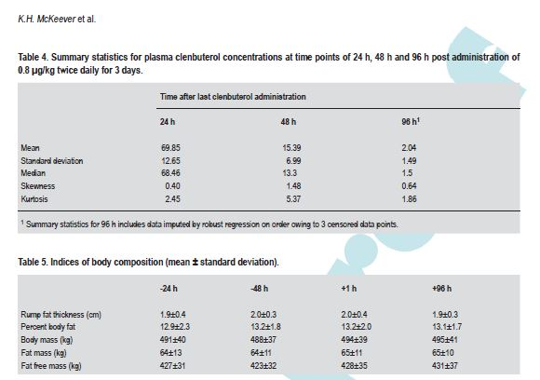
Figure 2. From Gordon et al., 2007, some body composition parameters.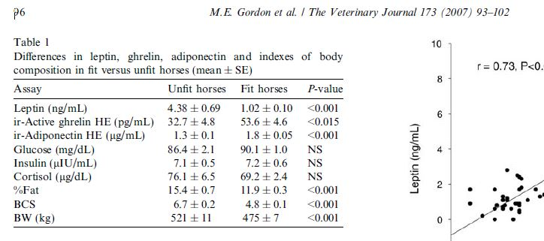

Figure 3. Excel spreadsheet showing body weights from other studies from the Rutgers laboratory.
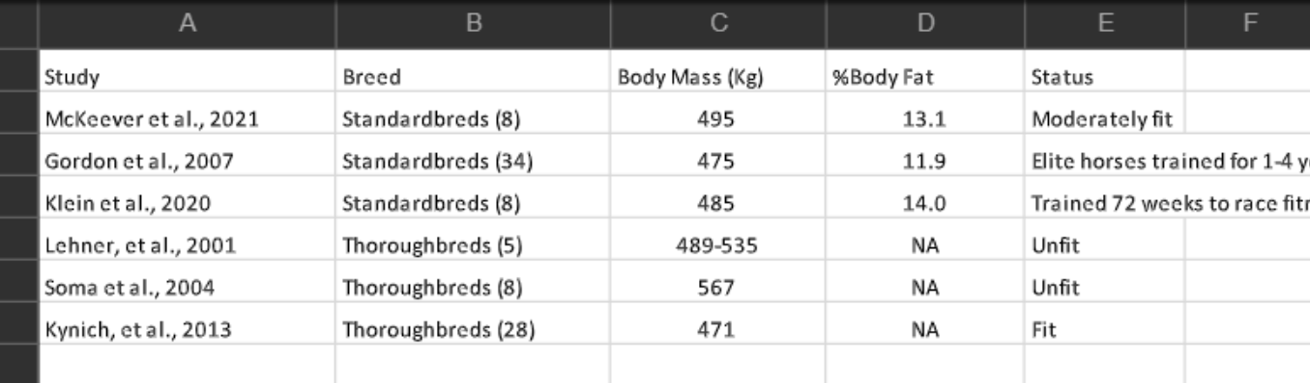

Figure 4. There is no physiologic difference in cardiovascular, endocrine and metabolic responses to exercise in Standardbreds from 4- 16 years.
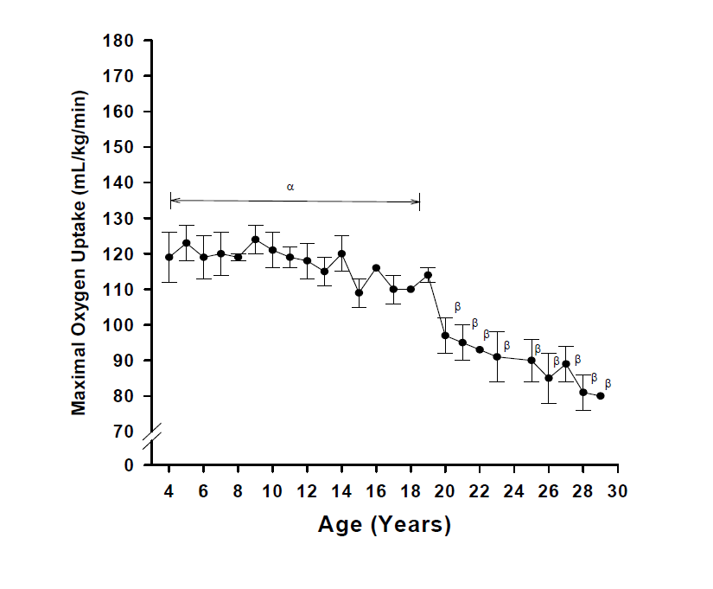
APPENDIX E
RMTC Controlled Therapeutic Medication Weight and ages of horses used to establish the threshold
RMTC Substance | Weight of Study Horses (kg) | Age of Study Horses (yr) | Breed | Reference
Acepromazine | 528 +/- 42 | 4 - 7 | TB | Knych et al., 2018
Albuterol | 442 – 489 | 4 - 8 | TB | Weider et al., 2014
Betamethasone | Not given | Not given | TB | RMTC Online Publication
Butorphanol | 500 +/-25 | 3 - 8 | TB | Knych et al., 2012
Cetirizine | 474 – 590 | 4 - 9 | TB | Knych et al., 2016
Cimetidine | 429 – 620 | 4 - 9 | TB | Knych et al., 2016
Clenbuterol | 470 +/-25 | 2 - 6 | TB | Knych et al., 2014
Dantrolene | 582 +/- 51 | 10 +/- 4 | TB | Knych et al., 2010
Detomidine | Unknown | Unknown |  | Unknown
Dexamethasone | 523.5 +/-44 | 6 - 10 | TB | Soma et al, 2012
DMSO | Unknown | Unknown |  | Unknown
Flunixin | 535 +/-33 | 4 - 7 | TB | Knych et al., 2014
Furosemide
Glycopyrrolate | 445 – 510 | 4 - 9 | SB | Rumpler et al., 2010
Isoflupredone | 492 – 600 | 4 - 8 | TB | Knych et al., 2016
Ketoprofen | 512 +/- 31 | 4 - 7 | TB | Knych et al., 2015
Lidocaine | Not given | Not Given |  | RMTC data provided by Mary Scollay
Mepivicaine | Unknown | Unknown |  | FEI detection time
Methocarbamol | 468 – 605 | 5 - 10 | TB | Rumpler et al., 2013
Methylpred | 492 – 600 | 4 - 8 | TB | Knych et al., 2013
Omeprazole | 429 – 620 | 4 - 9 | TB | Knych et al., 2016
Phenylbutazone | 501 +/- 36 | 3 - 6 | TB | Knych et al., 2019
Prednisolone | Not given | 13 - 30 | Mixed | Unknown
Procaine | na | na
Triamcinolone | Not given | 3 - 6 | TB | Knych et al., 2013
Xylazine | 419 – 610 | 4 - 7 | TB | Knych et al., 2016

APPENDIX F
RMTC Controlled Therapeutic Medication Thresholds that are Permissive of Administration within the Published Withdrawal Period
RMTC Substance | Permissive of Administration within the Withdrawal period |  | Reference
Acepromazine | possible |  | Knych et al., 2017
Albuterol | at 24 h 6/6 horses under thr |  | Weider et al., 2014
Betamethasone | at 96h 12/12 under thr |  | Knych et al., 2017
Butorphanol | possible at 6 h |  | Knych et al., 2012
Cetirizine | at 24h 8/9 below thr |  | Knych et al., 2016
Cimetidine | possible at 24h |  | Knych et al., 2016
Clenbuterol | possible |  | Knych et al., 2014
Dantrolene | at 36 h possible |  | Knych et al., 2010
Detomidine | Unknown |  | unknown
Dexamethasone | at 48 h 68/75 below thr |  | McClure et al., 2021
DMSO | Unknown |  | unknown
Flunixin
Furosemide
Glycopyrrolate | at 24h 8/8 below thr |  | Rumpler et al., 2010
Isoflupredone | at 48h 12/12 below thr |  | Knych et al., 2016
Ketoprofen | at 24 h 8/8 below thr |  | Knych et al., 2015
Lidocaine | at 48h 6/6 below thr |  | RMTC data provided by Mary Scollay
Mepivicaine
Methocarbamol
Methylpred | at 6 days for ankles and knees |  | Machin et al., 2018
Omeprazole
Phenylbutazone
Prednisolone
Procaine
Triamcinolone | at 5 d 12/12 below thr |  | Knych et al., 2013
Xylazine

APPENDIX G
References

Beekley, M.D., J.M. Ideus, W.F. Brechue, C.F. Kearns, K.H. McKeever. Chronic clenbuterol administration alters myosin heavy chain composition in Standardbred mares. The Veterinary Journal 165: 234-239, 2003.
Betros, C.L., K.H. McKeever, C.F. Kearns, and K. Malinowski. Effects of ageing and training on maximal heart rate and VO2max Equine Veterinary Journal Suppl. 34:100-105, 2002.
Cornelisse CJ, Robinson NE, Berney CE, Kobe CA, Boruta DT, Derksen FJ. 2004. Efficacy of oral and intravenous dexamethasone in horses with recurrent airway obstruction. Equine Veterinary Journal 36:426-30.
Derksen FJ, Olsezewski MA, Robinson NE, Berney C, Hakala JE, Matson CJ, Ruth DT. 1999. Aerosolized albuterol sulfate used as a bronchodilator in horses with recurrent airway obstruction. American Journal of Veterinary Research 60:689-93.
Edwards JGT, Newton JR, Ramzan PHL, Pilsworth RC, Shepherd MC. 2003. The efficacy of dantrolene sodium in controlling exertional rhabdomyolysis in the Thoroughbred racehorse. Equine Veterinary Journal 35:707-710.
Gordon, M.E., C.L. Betros, H.C. Manso, K.H. McKeever. Plasma leptin, ghrelin, and adiponectin concentrations in fit vs. unfit Standardbred mares. The Veterinary Journal, 173:91-100, 2007.
Kearns, C.F. and K.H. McKeever Clenbuterol diminishes aerobic performance in horses Medicine and Science in Sport and Exercise, 34:1976-1985, 2002.
Kearns, C.F. and K.H. McKeever. Clenbuterol and the horse revisited. The Veterinary Journal, 182:384-391, 2009.
Kearns, C.F., K.H. McKeever, H. John-Alder, T. Abe, W. Brechue. Relationship between body composition, blood volume, and maximal oxygen uptake. Equine Veterinary Journal Suppl. 34:485-490, 2002.
Kearns, C.F., K.H. McKeever, H. John-Alder, T. Abe, W. Brechue. Relationship between body composition, blood volume, and maximal oxygen uptake. Equine Veterinary Journal Suppl. 34:485-490, 2002.
Kearns, C.F., K.H. McKeever, K. Malinowski, M.B. Struck, T. Abe Chronic administration of therapeutic levels of clenbuterol acts as a repartitioning agent. Journal of Applied Physiology 91:2064-2079, 2001.
Kearns, C.F., K.H. McKeever, K. Malinowski, M.B. Struck, T. Abe Chronic administration of therapeutic levels of clenbuterol acts as a repartitioning agent. Journal of Applied Physiology 91:2064-2079, 2001.
Kearns, C.F., K.H. McKeever, K. Malinowski. Changes in adiponectin and leptin are associated with changes in fat mass after clenbuterol treatment in horses. Medicine and Science in Sport and Exercise 38:262-267, 2006.
Kearns, C.F., K.H. McKeever, T. Abe. Overview of horse body composition and muscle architecture- implications for performance. The Veterinary Journal 1 64:224-234, 2002.
Kearns, C.F., K.H. McKeever, T. Abe. Overview of horse body composition and muscle architecture- implications for performance. The Veterinary Journal 1 64:224-234, 2002.
Kearns, C.F., K.H. McKeever, V. Roegner, S.M. Brady and K. Malinowski Adiponectin and leptin are related to fat mass in horses The Veterinary Journal, 172: 460-465, 2006.
Kearns, C.F., K.H., McKeever, K. Kumagai, T, Abe. Fat-Free mass is related to one-mile race performance in elite Standardbred horses. The Veterinary Journal 163:260-266, 2002.
Knych HK, Arthur RM, McKemie DS, Seminoff K, Hamamoto-Hardman B, Kass PH. 2019. Phenylbutazone Blood and Urine Concentrations, Pharmacokinetics and Effects on Biomarkers of Inflammation in Horses Following Intravenous and Oral Administration of Clinical Doses. Drug Testing and Analysis doi: 10.1002/dta.2553.
Knych HK, Arthur RM, Steinmetz S, McKemie DS. 2015. Pharmacokinetics of ketoprofen enantiomers following intravenous and oral administration to exercised Thoroughbred horses. The Veterinary Journal doi: 10.1016/j.tvjl.2015.09.018
Knych HK, Harrison LM, White A, McKemie DS. 2015. Disposition of isoflupredone acetate in plasma, urine and synovial fluid following intra-articular administration to exercised Thoroughbred horses. DrugTesting and Analysis doi: 10.1002/dta.18
Knych HK, Mitchell MM, Steinmetz SJ, McKemie DS. 2013. Detection, pharmacokinetics and cardiac effects following administration of clenbuterol to exercised horses. Equine Veterinary Journal 46:380-385.
Knych HK, Seminoff K, McKemie DS, Kass PH. 2018. Pharmacokinetics, pharmacodynamics, and metabolism of acepromazine following intravenous, oral, and sublingual administration to exercised Thoroughbred horses. Journal of Veterinary Pharmacology and Therapeutics 41:522–535.
Knych HK, Stanley SD, Arthur RM, McKemie DS. 2016. Disposition of the anti-ulcer medications ranitidine, cimetidine, and omeprazole following administration of multiple doses to exercised Thoroughbred horses. Journal of Veterinary Pharmacology and Therapeutics doi: 10.1111/jvp.12328.
Knych HK, Stanley SD, Arthur RM, McKemie DS. 2016. Elimination of cetirizine following administration of multiple doses to exercised thoroughbred horses. Journal of Veterinary Pharmacology and Therapeutics doi: 10.1111/jvp.12318
Knych HK, Stanley SD, Harrison LM, McKemie DS. 2017. Pharmacokinetics of betamethasone in plasma, urine, and synovial fluid following intraarticular administration to exercised thoroughbred horses. Drug Testing and Analysis DOI 10.1002/dta.2170.
Knych HK, Stanley SDS, McKemie DS, Arthur RM, Kass PH. 2016. Pharmacokinetic and pharmacodynamics of xylazine administered to exercised thoroughbred horses. Drug Testing and Analysis doi: 10.1002/dta.2047
Knych HK, Vidal MA, Casbeer HC, McKemie DS. 2013. Pharmacokinetics of triamcinolone acetonide following intra-muscular and intra-articular administration to exercised Thoroughbred horses. Equine Veterinary Journal 45:715-720.
Knych, H. K., Casbeer, H. C., McKemie, D. S., Arthur, R. M. Pharmacokinetics and pharmacodynamics of butorphanol following intravenous administration to the horse. J. vet. Pharmacol. Therap. doi: 10.1111/j.1365-2885.2012.01385.x.
Leclere M, Lefebvre-Lavoie J, Beauchamp G, Lavoie J-P. 2010. Efficacy of oral prednisolone and dexamethasone in horses with recurrent airway obstruction in the presence of continuous antigen exposure. Equine Veterinary Journal 42:316-21.
Machin J, Duer WC, Maylin G, Fenger C, Wilson D, Ivey M, Berthold B, Allison S, Tobin T. 2018. Variability in plasma concentrations of methylprednisolone 6 days after intrasynovial injection of methylprednisolone acetate in racing horses: A field study. Equine Veterinary Journal 51(3):343-348.
Malinowski, K, C.F. Kearns, P.D. Guirnalda, V. Roegner, K.H. McKeever. Effect of chronic clenbuterol administration on immune function in horses. Journal of Animal Science 82: 3500-3507, 2004.
Malinowski, K., C.L. Betros, L. Flora, C.F. Kearns, K.H. McKeever. Effect of training on age-related changes in plasma insulin and glucose. Equine Veterinary Journal Suppl. 34:147-153, 2002.
Manjunath P, Shivaprakash BV. 2013. Pharmacology and Clinical Use of Dimethyl Sulfoxide (DMSO): A Review. International Journal of Molecular Veterinary Research doi: 10.5376/ijmvr.2013.03.0006.
McClure S, Fenger C, Kersh K, Brown B, Maylin G, Duer W, Dirikolu L, Brewer K, Machin J and TobinT. 2021. Dexamethasone serum concentrations after intravenous administration in horses during race training. Comparative Exercise Physiology In Press.
McKeever, K.H., Birks, E.K., Durando, M.M. Effects of a type-5 phosphodiesterase inhibitor on pulmonary artery pressure in race fit horses, Abstracts of the 10th International Conference on Equine Exercise Physiology in Comparative Exercise Physiology, 14:S69, 2018.

Nieto JE, Spier SJ, van Hoogmoed L, Pipers F, Timmerman B, Snyder JR. 2001. Comparison of omeprazole and cimetidine in healing of gastric ulcers and prevention of recurrence in horses. Equine Veterinary Education 13:260-264.
Olsen L, Bondesson U, Brostrom H, Tjalve H, Ingvast-Larsson C. 2008. Cetirizine in horses: Pharmacokinetics and pharmacodynamics following repeated oral administration. The Veterinary Journal 177:242-249.
Plant, D.R., C.F. Kearns, K.H. McKeever, G.S. Lynch. Therapeutic clenbuterol treatment does not affect Ca2+-sensitivity of permeablized fast skeletal muscle fibers from exercise trained or untrained horses. Journal of Muscle Research and Cell Motility, 24: 471-476, 2003.
Rumpler M, Sams RA, Colahan P. 2011. Pharmacokinetics of glycopyrrolate following intravenous administration in the horse. Journal of Veterinary Pharmacology and Therapeutics 34:605-608.
Rumpler MJ, Colahan P, Sams RA. 2013. The pharmacokinetics of glycopyrrolate in Standardbred horses. Journal of Veterinary Pharmacology and Therapeutics 37, 260--268. doi: 10.1111/jvp.12085.
Rumpler, MJ, Colahan, P, Sams, RA. 2013. The pharmacokinetics of methocarbamol and guaifenesin after single intravenous and multiple-dose oral administration of methocarbamol in the horse. J Vet Pharmacol Therap doi 10.1111/jvp.12068
Sleeper, M., C.F. Kearns, K.H. McKeever. Chronic clenbuterol administration negatively alters cardiac function in the horse. Medicine and Science in Sport and Exercise 34:643-650, 2002.
Soma LR, Uboh CE, Guan F, LuoY, Teleis D, Runbo L, Birks EK, Tsang DS, Habecker P. 2004. Tissue distribution of clenbuterol in the horse. Journal of Veterinary Pharmacology and Therapeutics 27:91-98.
Soma LR, You Y, Robinson MA, Boston RC. 2018. Pharmacokinetics of intravenous, subcutaneous, and topical administration of lidocaine hydrochloride and metabolites 3-hydroxylidocaine, monoethylglycinexylidide, and 4-hydroxylidocaine in horse. Journal of Veterinary Pharmacology and Therapeutics 41:825-837.
Walker, A., S.M. Arent, and K.H. McKeever. Maximal aerobic capacity (VO2MAX) in horses: a retrospective study to identify the age-related decline. Comparative Exercise Physiology. 6: 177-181, 2010.
Weider ME, Paine SW, Hincks PR, Pearce CM, Scarth J, Hillyer L. 2014. Detection and Pharmacokinetics of salbutamol in thoroughbred racehorses following inhaled administration. Journal of Veterinary Pharmacology and Therapeutics 38:41-47. Doi:10.1111/jvp.12150

APPENDIX F:
Detailed critique of the RMTC Controlled Medication Schedule, by Substance

